Module VIII
Workbook

NAILD LS I

HID to LED…Indoor and Outdoor

Exercise #1a – Comparing HID Sources

Exercise #2 – Why Objects Look Different

Under Different Light Sources

Exercise #3a – Comparing an Indoor HID to LED Conversion

Exercise #3b – Comparing an Outdoor HID to LED Conversion

Copyright © NAILD. All Rights Reserved.

These Exercises follow the content in Chapter 1:

Exercise #1 – Comparing HID Sources

 | Watts | Lamp Code | ANSI/Ballast Reference Code | Initial Lumens | Mean Lumens | Lumen  Maint.  Factor | Rated Avg. Life | CCT | CRI
Mercury
Vapor
Quartz Metal Halide
High Pressure Sodium
Ceramic Metal Halide

Step 1: Identify the catalog you used __________________________________

Step 2: Choose all lamps of the same wattage

Step 3: Fill in the chart and calculate the Lumen Maintenance Factor

Step 4: Look in the catalog to determine what the ANSI/Ballast Reference Code means

Step 5: If you didn’t pick one, find at least one Protected Lamp

Step 6: What does “E”, “S” and “O” mean in the Lamp or ANSI code?

Step 7: How many lamps can you find with the same Ballast Code: M59 (MH400/U)

Name them all here:

Exercise #2 – How Lamp Chemistry Affects the Colors We See

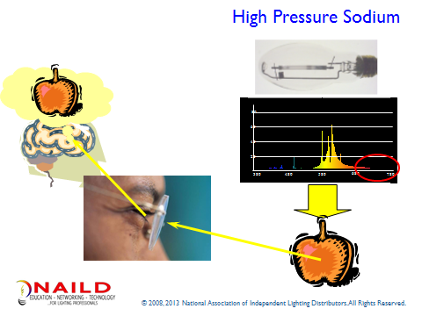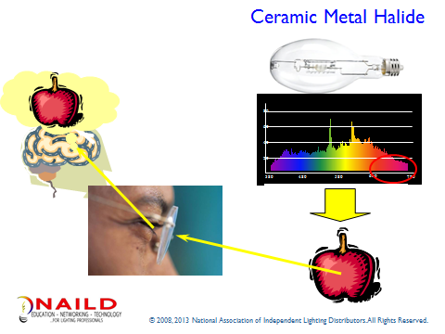

Explain why the same object, an apple, can look different under different light sources:

Reason #1: ______________________________________________

______________________________________________

Reason #2: ______________________________________________

______________________________________________

Exercise #3a – Comparing HID to LED –Indoors – using the data provide, fill in the Table.

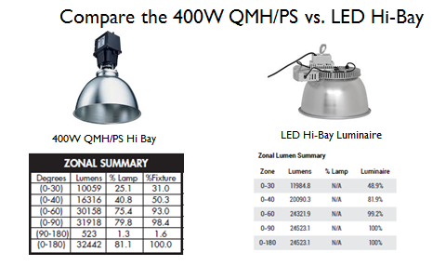

 | 400W QMH PS | 240W HiBay LED
System Wattage | 458 | 240
Initial Lumens | 40,000 | 24,523
Mean Lumens | 28,000 (70% @ 8K hours) | N.A.
Fixture Efficiency | ? __________ | ? _________

Exercise 3a
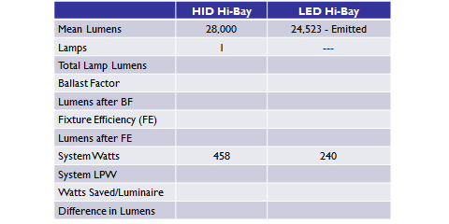

Exercise #3b – Comparing HID to LED –Outdoors – using the data provide, fill in the Table.

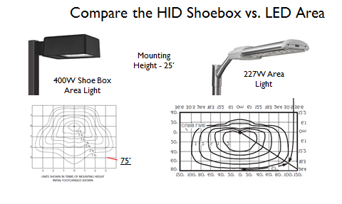

 | 400W QMH PS | 227W Area Light
System Wattage | 458 | 227
Initial Lumens | 40,000 | 15,578
Mean Lumens | 28,000 (70% @ 8K hours) | N.A.

Exercise 3b
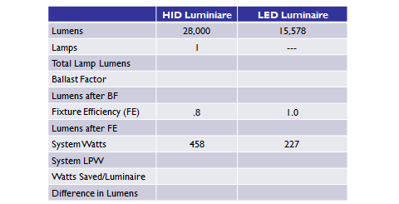

This concludes Module VIII –

