Module VII
Workbook

NAILD LS I

Linear Fluorescent Sources

Chapter 1 – Lamps, Ballasts and Luminaires

Chapter 2 – How Fluorescent Lamps Create Light

Chapter 3 – Drivers and Ballasts

Chapter 4 – Comparing Fluorescent Systems and LED Systems

Copyright © NAILD. All Rights Reserved.

Chapter 1 – Bucket of Lamps

The following list contains suggestions for the lamps you could use in this look up exercise.

Using your preferred lamp catalog, research these 5 lamps and fill in the table below:

Linear Fluorescent:
F32T8/RE830 – Energy Saver 25w
F28T5/RE841
F54T5/RE850/HO
F96T12/RE841
F96T12/RE850/HO
4’ T8 LED

Feel free to adjust the list of lamps as you feel appropriate to your business. This exercise focuses on helping you learn how to read the lamp catalog. Further, it seeks to demonstrate how each lamp type provides slightly different information in the catalog descriptions. Finally, you will see that each of the major manufacturers has a slightly different way of organizing the information in their catalog.

Should you use more than one manufacturer for some of these lamp families, just note it. Remember, you are building your Reference Library, so be sure to personalize in every way possible.

Calculate the Lumen Maintenance Factor (Mena or Design Lumens/Initial Lumens)

 | Watts | CCT | Length | Base | Initial  Lumens | Mean  Lumens | Lumen  Maint.  Factor | Rated  Avg.  Life | CRI
F32T8/RE830-25W
F28T5/RE841
F54T5/RE850/HO
F96T8/RE841
F96T8/RE850/HO
4’ T8 LED

Linear Fluorescent – Exercise 2 (Answer key on next page)

Now that you have completed the “Bucket of Lamps” exercise, let’s see what we can discover from what you learned in the lamp catalog about each of these lamps.

- All of the linear fluorescent lamp codes begin with the same letter: ___________

- The number following this lamp family designation can be two different things:

- For bi-pin fluorescent lamps, this number is the lamp’s nominal _____________

- For “single pin” and “double recessed contact” base lamps, this number is the ____________ of the lamp in ____________.

- The Rated Average Life based on ANSI standards is _____ hours per start. _______ hours per start is an industry developed standard based on typical operating hours for fluorescent lamps.

- Figuring out how much light output remains when a lamp reaches 40% of its Rated Average Life is called Lamp Lumen Depreciation (LLD). This % is found by dividing Mean or Design Lumens by Initial Lumens, for example: (Note the difference in lumen maintenance for the two phosphor types.)

F32T8/RE841: 2800 Mean Lumens / 2950 Initial Lumens = _____ % (Rare Earth Phosphors)

(Look at the chart you developed and calculate the LLD for each linear source. What do you discover from this exercise?)

- The lamp’s Color Temperature, or CCT (Correlated Color Temperature) could be: 2700K, ________ K, _______ K, ________ K, _______ K, 6500K, or even 7500K.

- The quality of the phosphors helps determine the CRI of the fluorescent lamp. The CRI of lamps can range from the mid 50’s to the high 90’s. A halo phosphor lamp, like Cool White, has a CRI
of _________ . Rare Earth (the RE designation in the ANSI lamp code), otherwise known as
tri-chromatic phosphor lamps have a designation for both the CRI and the CCT. For example,
the CRI for an F32T8/741 would be ______ . The CRI for an F32T8/841 would be _______.
The CRI for an F32T8/950 lamp would be _______ .

So now you know that the first of those three numbers tells you the class of the lamp’s ________, and the remaining two numbers tell you the lamp’s ____________ ______________________.

Linear Fluorescent – Exercise 2 – ANSWER KEY

Now that you have completed the “Bucket of Lamps” exercise, let’s see what we can discover from what you learned in the lamp catalog about each of these lamps.

- All of the linear fluorescent lamp codes begin with the same letter: ___”F”___

- The number following this lamp family designation can be two different things:

  - For bi-pin fluorescent lamps, this number is the lamp’s nominal __“wattage”__

  - For “single pin” and “double recessed contact” base lamps, this number is the __”length”__ of the lamp in _”inches”_.

- The Rated Average Life based on ANSI standards is __”3”__ hours per start. _”12”_ hours per start is an industry developed standard based on typical operating hours for fluorescent lamps.

- Figuring out how much light output remains when a lamp reaches 40% of its Rated Average Life is called Lamp Lumen Depreciation. This % is found by dividing Mean or Design Lumens by Initial Lumens, for example:

2800 Mean lumens / 2950 Initial lumens = __ 95% __

- The lamp’s Color Temperature, or CCT (Correlated Color Temperature) could be: 2700K, _3000_ K, _3500_ K, _4100_ K, _5000_ K, 6500K, or even 7500K.

- The quality of the phosphors helps determine the CRI of the fluorescent lamp. The CRI of lamps can range from the mid 50’s to the high 90’s. A halo phosphor lamp, like Cool White,
has a CRI of__ (see catalog) 62__ .

Rare Earth (the RE designation in the ANSI lamp code), otherwise known as tri-chromatic phosphor lamps have a designation for both the CRI and the CCT. For example, the CRI for an F32T8/741 would be __ (see catalog) 75-78__ . The CRI for an F32T8/841 would be __ (see catalog) 82-86__. The CRI for an F32T8/950 lamp would be __ (see catalog) 95-97__ .

So now you know that the first of those three numbers tells you the class of the lamp’s __”CRI”__, and the remaining two numbers tell you the lamp’s __”color”__ __”temperature”__.
Key Takeaways:

- Differentiate the meaning of the number following “F”, for bi-pin, mini bi-pin, and all other fluorescent lamp types. (e.g. F32T8/841 vs. F48T12/CW/ES)
- Develop a question, like: “Why the CRI of the lamps designated 7xx or 8xx is always at least 75, why?
- Identify where the Footnotes are located in the catalog and look up at least five Footnotes for linear fluorescent lamps. Make notes below for what you learned. Remember this is not a course to take and put on shelf, this is a resource that you will continue to build on long after the course is completed.

The Footnotes I Found and What I learned:

- Footnote # ___ Page # _____ Lamp Family ______________

What I learned:

- Footnote # ___ Page # _____ Lamp Family ______________

What I learned:

- Footnote # ___ Page # _____ Lamp Family ______________

What I learned:

- Footnote # ___ Page # _____ Lamp Family ______________

What I learned:

- Footnote # ___ Page # _____ Lamp Family ______________

What I learned:

Chapter 2 – Fluorescent Lamp Operation

Exercise 3, Personalize Your Understanding

After you have completed Chapter 2 – How a Fluorescent Lamp Operates, take a few moments and put what you learned into your own words.

Write down what you remember about how a fluorescent lamp creates light, including what is involved and how it eventually fails. This can be verbal. You can draw pictures. Feel free to use color pens, or crayons. Just have fun with it.

Chapter 2: Exercise #4 – Comparing the effect of temperature on fluorescent and LED systems

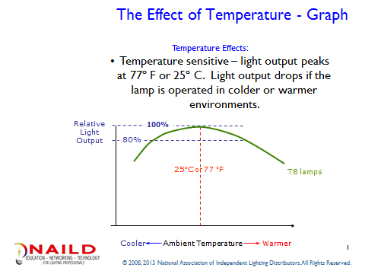

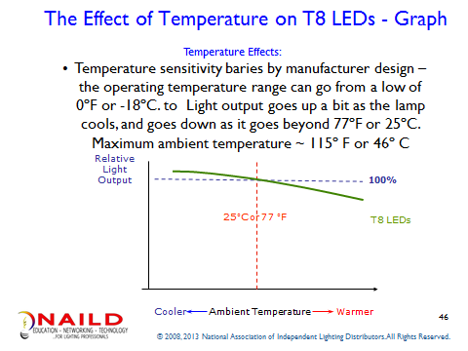

Based on the above two graphics explain how LEDs and Fluorescent lamps have a similar reaction to temperature:

Based on the above two graphics explain how LEDs and Fluorescent lamps have a different reaction to temperature:

Chapter 3 – Exercise #5: Compare the difference between Ballasts Factor and Power Factor

- Ballast Factor: (What does it do and provide an example of how ballast factor affects the light output of a T8 lamp when compared to its light output in the laboratory under controlled test conditions.

- Power Factor: What is it? What does it do? Why does it matter when putting a retrofit job together? Give an example of how a High Power Factor differs from Normal Power Factor.

Chapter 4: Exercise 6a (Do each problem first, then, check the online solution)

Exercise #3a: Comparing a 32W Fluorescent Lamp on a Low Watt ballast versus a T8 LED lamp operating on that same ballast, in a 2x4 parabolic louvered Troffer

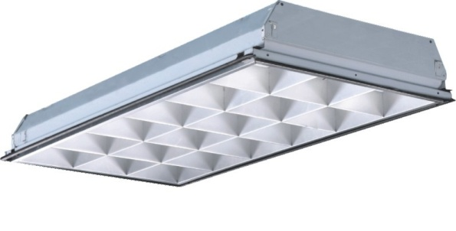

3 - F32 lamps 3 – T8 LED lamps
Low Watt Electronic Ballast Low Watt Electronic Ballast
2600 design/mean lumens 1400 design/mean lumens
x 3 lamps x 3 lamps

lumens Net lumens

x .77 Ballast Factor (BF)
This number includes the ballast factor &

Lumens after BF fixture efficiency (there may be some variance)

. x .733 Fixture Efficiency (FE) 43.5 System Watts

Lumens after FE Net lumens / 43.5 system Watts =

71 System Watts system lumens per watt

Net lumens / 71 system Watts =

System Lumens per Watt

What is the energy savings per fixture? _____________

What is the difference in light output (lumens) per fixture? ______________

Chapter 4: Exercise 6b

Exercise #3b: Comparing a 32W Fluorescent Lamp on a Low Watt ballast in a 2x4 parabolic louvered Troffer versus a T8 LED Retrofit Kit

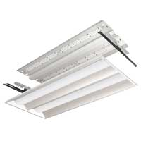

3 - F32 lamps LED Retrofit Kit
Low Watt Electronic Ballast 0-10v or Line Voltage Dimming Driver
2600 design/mean lumens 4100 Emitted lumens
x 3 lamps

lumens Net lumens

x .77 Ballast Factor
This number includes fixture efficiency

42 System Watts

. x .733 Fixture Efficiency

Net lumens Net lumens / 42 system Watts =

71 System Watts system lumens per watt

Net lumens / 71 system Watts =

System Lumens per Watt

What is the energy savings per fixture? _____________

What is the difference in light output (lumens) per fixture? ______________

What else will be different as a result of this retrofit? ______________________________ (Do a demo)
Chapter 4: Exercise 6c

Exercise #2: Comparing a 32W Fluorescent Lamp on a Low Watt ballast in a 2x4 parabolic louvered Troffer versus a LED Fixture
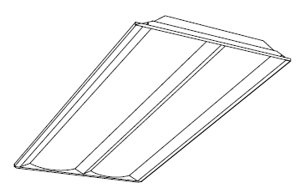

3 - F32 lamps LED Luminaire
Low Watt Electronic Ballast 0-10v or Line Voltage Dimming Driver
2600 design/mean lumens 4900 Emitted lumens
x 3 lamps

lumens Net lumens

x .77 Ballast Factor
This number includes fixture efficiency

42 System Watts

. x .733 Fixture Efficiency

Net lumens Net lumens / 42 system Watts =

71 System Watts system lumens per watt

Net lumens / 71 system Watts =

System Lumens per Watt

What is the energy savings per fixture? _____________

What is the difference in light output (lumens) per fixture? ______________

What else will be different as a result of this retrofit? ______________________________
(Always do a demonstration)
This concludes Module VII

