Module VI
Workbook

NAILD LS I

Transition From Filament to LED

Exercise #1 – Comparing Sources

Exercise #2a & 2b – Measuring Lamp FCs & Watts

Exercise #3 – Measuring Fixture FCs and Watts

Exercise #4a – Spacing to Mounting Height

Exercise 4b – Payback and ROI

Copyright © NAILD. All Rights Reserved.

Exercise 1: Complete this table based on the catalog information provided and then check your work in Chapter 1 of the Module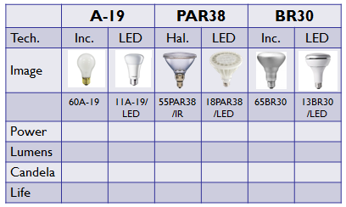

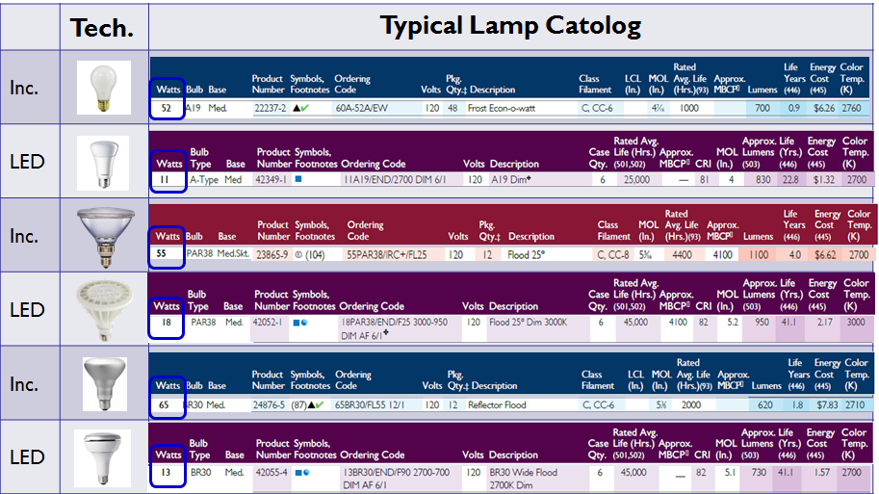

Exercise #2a – Observing the Between the Color Appearance of Filament Sources vs. LED

Step #1: Choose a PAR Lamp:
- PAR38

Step #2: Ensure the lamps have the same characteristics:

- If you choose a 60PAR38/IRFL25 (3000K) match it with an equiv. 18PAR38/LED/FL25 (3000K)

Step #3: Gather the necessary tools to compare. Ideally two Kill-a-Watt Meters to measure wattage, a Digital Light Meter to measure footcandles (FC) and two trouble lights with the cages removed/sockets with cord and plug or lamp comparator and a power strip.

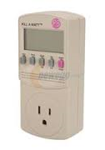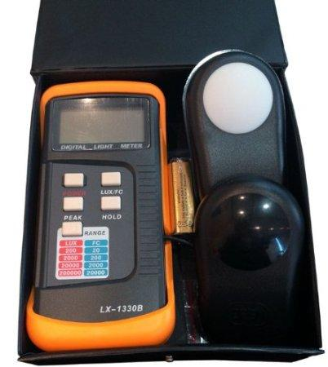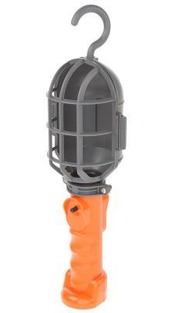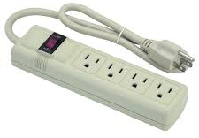

Kill-a-Watt Digital Light Meter Trouble Light Power Strip (note orientation of the
Meter sockets) Allows you to use two Meters
side-by-side

You will make these tools a permanent part of your work. Every time a new product comes in you will test it out

Step #4: Compare the light sources – for apparent brightness, measured watts and measured footcandles.

Step #5: Record your data in the table below, including the data from the lamp catalog. Compare your
data.

What did you learn? What results did you get?

 | Lamp Type #1 | Lamp Types #2
Lamp Type
Product Code
Appears Brighter
Wattage
Color Temperature
Measured Watts
Measured Footcandles (FC)

My findings:

Bonus: If you have access to an LED lamp that changes Color Temperature when it dims, repeat the experiment with the filament source and this lamp and then do it again with the other LED lamp.

Exercise #2b – Comparing Filament and LED BR30 or A-19 lamp

Step #1: Choose an A-19 or BR30 lamp:

Step #2: Ensure the lamps have the same characteristics:

- If you choose a 65BR30 (2700K) match it with an equiv. BR30LED (2700K)

Step #3: Gather the necessary equipment to compare.

Kill-a-Watt Digital Light Meter Trouble Light Power Strip (note orientation of the
Meter sockets. Allows you to use two Meters
side-by-side

Step #4: Compare the light sources – for apparent brightness, measured watts and measured
footcandles.

Step #5: Record your data in the table below, including the data from the lamp catalog. Compare your data.

What did you learn? What results did you get?

 | Lamp Type #1 | Lamp Types #2
Lamp Type
Product Code
Appears Brighter
Wattage
Color Temperature
VaMeasured Watts
Measured Footcandles (FC)

My findings:

Bonus: If you have access to an LED lamp that changes Color Temperature when it dims, repeat the experiment with the filament source and this lamp and then do it again with the other LED lamp.

Exercise #3 – Comparing Filament and an LED Retrofit Kit or Recessed Downlight

This is a little more complicated and will probably require the help of a licensed electrician. If possible measure the wattage of the retrofit kit or the new recess downlight before you put it into the ceiling. After that everything else remains pretty much the same. If you use a screw in retrofit kit for a recessed can, you can do it yourself.

Step #1: Choose either a new recessed downlight or a retrofit kit for an existing recessed downlight (some of the have a medium screw base connector making it easy to measure the wattage using your trouble light. Or get two inexpensive downlights with a medium base socket.

Step #2: Ensure the filament lamp in the downlight and the retrofit kit or new recessed downlight have the same or similar characteristics.

- If you choose a 65BR30 (2700K) match it with an equiv. retrofit kit or new luminaire that matches a 65w source

Step #3: If you have this type of luminaire in the ceiling in your offices, use them for the test. Otherwise you can attempt to test similarly to Exercise 1 and 2.

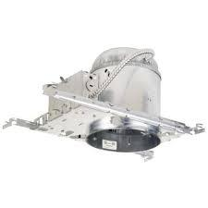

Kill-a-Watt Digital Light Meter Recessed Can Power Strip (note orientation of the
Meter sockets. Allows you to use two Meters

Step #4: Compare the light sources, as you did in Exercise 2. If it’s a PAR Lamp you’ll need to record Candela, if it’s a 65BR30 incandescent versus a 13BR30 LED you won’t need the Candela data.

Step #5: Record your data in the table below, including the data from the lamp catalog. Compare your data.

What did you learn? What results did you get?

 | Fixture Type #1 | Fixture Types #2
Fixture Type
Product Code
Appears Brighter
Catalog Watts
Catalog Lumens
Catalog Candelas
Color Temperature
Measured Watts
Measured Footcandles (FC)

My findings:

Exercise #4a: Delivered Lumens per Watt

Step #1: Use the data you assembled from Exercise 2a or 2b. Enter it again below:

 | Lamp Type #1 | Lamp Types #2
Lamp Type
Product Code
Appears Brighter
Catalog Watts
Catalog Lumens
Catalog Candela
Color Temperature
Measured Watts
Measured Footcandles (FC)

Measured Footcandles (FC) | Lamp Type #1 | Lamp Types #2
Catalog Lumens
Catalog Watts
Divide Lumens by Watts
= “delivered lumens/watt”

Why? Because there are no luminaires in the way. This is absolute photometry.

Step #2: Do this again, only this time use the “measure watts” and the “measured footcandles”
(Technically, we don’t do this calculation, but the results, always present some interesting questions.)

Measured Footcandles (FC) | Lamp Type #1 | Lamp Types #2
Measured Footcandles (FC)
Measured Watts
Divide FC by Watts
= “delivered FC/Watt”

Exercise 4b: Payback and ROI

Reminder: Payback = Cost or Investment divided by Savings (Sometimes we multiply by 12 to put the answer in months..
ROI = Savings divided by Cost x 100%

Fact #1: Let’s use a PAR Lamp example and say that the existing system uses a 60PAR38/IR/FL25. The
proposed system uses an 18PAR36/LED/FL25. The annual operating hours in this retail shop are
5,000 and the “blended rate’ per kWh = $0.10.
Fact #2: The value of One Watt saved or spent = Annual Hours/1,000 x the “blended rate” / kWh.
5,000 annual hours /1000 = 5 units of 1000 hours x $0.10 = $0.50 per watt per year.
Fact #3: The 60PAR38/IR costs $8, lasts 4,000 hours. The 18PAR38LED costs $22, lasts 45,000 hours.
Fact #4: It costs $5 according to the shop owner to change a light bulb. But this is not a consideration in
the Payback and ROI equation. These people are on staff and they have to be paid anyway.

Step#1: Fill in the chart below:

 | Lamp Type #1 | Lamp Types #2
Lamp Type
Catalog Watts
Value of One Watt
Annual Electric Cost/per socket
Energy Savings
Lamp Cost
Lamps needed get to 5,000 hours
Year 1 Lamp Cost
Incremental Cost
Incrmntl. Cost/Savings x12 = Payback
Savings/Incrmntl. Cost x 100% = ROI

What do you know now?

This concludes Module VI –

