Module V

WORKBOOK

NAILD LS I

LED Basics

Exercise #1 – Effect of Temperature at the P/N Junction on Life

Exercise #2 – Building Your LED Vocabulary

Exercise #3 – Calculating Emitted or Delivered Lumens

Exercise #4 – “Treasure Hunt”

Exercise #5 – Comparing Life and Lumen Maintenance

Copyright © NAILD. All Rights Reserved.

Exercises 1a, 1b, & 1c, follow the content in Chapter 2,

Exercise #1a – The Effect of Temperature on LED Life

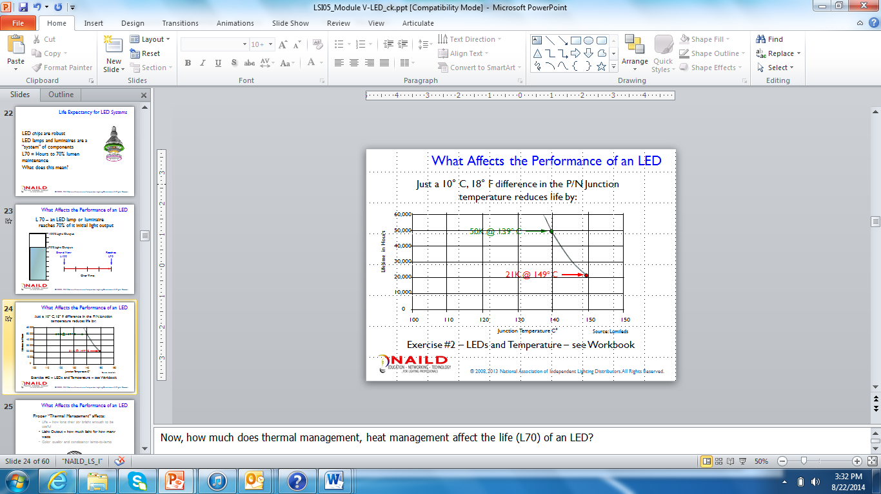

Step 1: Divide 21,000 hours life by 50,000 hours “useful life” to L70 (you’ll learn about this later).

Step 2: Subtract that number from 100%.

Look on the next page for the step-by-step solution.

ANSWER: This is how your problem solution should look:

21K hrs. to L70 /50K hrs. to L70 = .42 or 42%.

100% - 42% = 58% loss of life in hours.

So allowing the LEDs to overheat by just 10° C or 18° F, caused the
LEDs “useful life” to drop from 50K hours to 21 K hours – 58%!

Exercise #1b – The Effect of Temperature on Light Output

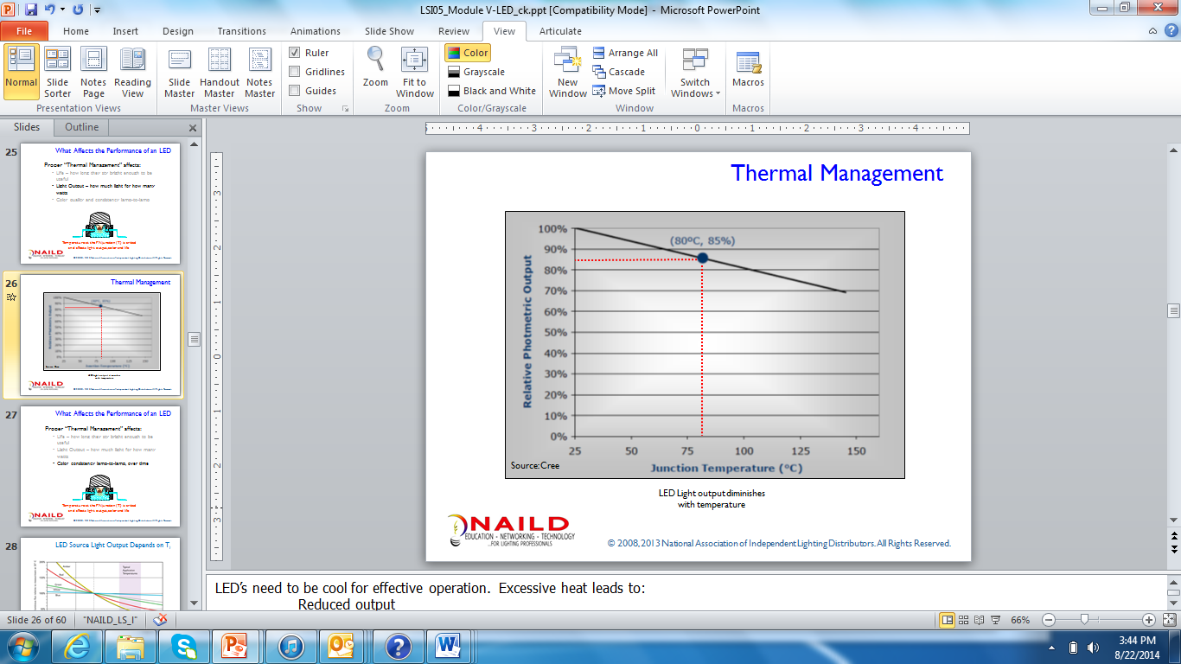

In the laboratory, the light output of an LED chip is measured when the P/N Junction temperature is 25° C, 77° F. However, when the chip is in a device creating lighting in a lamp or luminaire, that temperature is different. At 80° C, 176° F at the P/N Junction, the graph above shows that the LED light output drops by 15% to 85% of its original light output.

Approximately, what percentage of light output is lost when the Junction Temperature reach 100° C, 212° F?

______ ? (see correct answer on the next page)

Answer: A 20% loss of light output or, said another way, 80% of the original light output. Just draw a straight line from 100° C up through the slanted line and read the % light output on the vertical axis of the graph.

This is all laboratory data. Field conditions could be more severe if the LED luminaire does not have a proper heat sink. Or the luminaire or lamp is not properly installed and allowed to “breathe”, or both.

Exercise #1c – The Effect of Temperature on Color Consistency

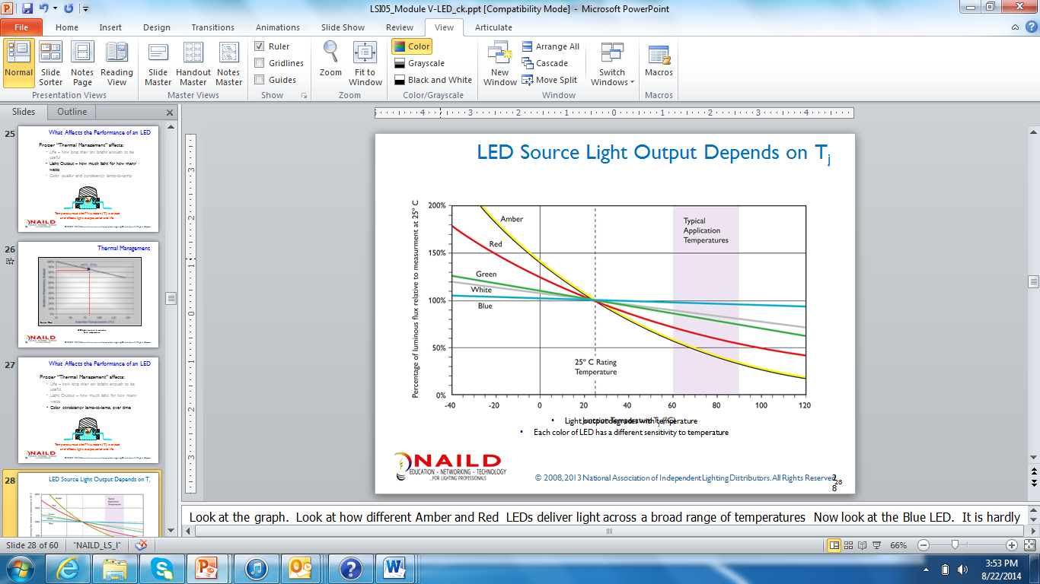

2c. Which two LED types are most affected by temperature? ________ ________

2c. Which two LED types are least affected by temperature? ________ ________

(Correct answer on the next page.)

ANSWER:

Most Affected: Amber and Red, note the slope of the line going up in the cold and down in the heat.

Least Affected: Blue and White, note that the Blue LED has virtually no change in light output whether the temperature is “hot” or “cold”.

This stable light output for a broad range of temperatures, combined with specially designed phosphors, is why the “blue LED” is used to efficiently create white light.

Exercise #2: LED Terminology – (First 10 cover chapters 1 & 2, Second 10 cover later chapters)

For this exercise, you will need to photocopy the LED Terms and the Definitions on pages 9-12, so that you can keep your Workbook intact.

Step one: Photocopy and cut out the LED Terms and the Definitions on pages 9-12.

Step two: On your own, match the LED Terms and the Definitions.

Step three: Using the PowerPoint presentation as a reference, confirm your matches and then, using the 3 x 5 cards glue the LED Term to one side and its Definition to the other to create your twenty Lighting Terminology Flash Cards.

Physical Props:

- 3 x 5 cards
- Adhesive, glue stick or rubber cement
- Workbook Terms and Definitions

Emitter Package (LED Assembly or LED Device) | Thermal Management
P/N Junction | L70
Driver | LED System (Lamp or Luminaire)
Static White LEDs | Static Color LEDs
Dynamic Color LEDs | Dynamic White LEDs

Typically, traditional light source consist of component parts: ballast, lamp, fixture. We look at an LED lamp or luminaire as one thing. It is a complete package or _________ ________. | This set of techniques helps control P/N junction temperatures. Control of the P/N junction temperature affects three performance characteristics of LEDs:  - Life  - Light Output  - Color Consistency
The components of this device include: the LED chip or die, the heat sink to draw heat away from the LED chip, primary optic to focus light out of the LED chip, and an electrical connection to the driver. | This is an electronic circuit that converts input power (watts) into a current source, which remains constant regardless of fluctuations in voltage. It also protects the LED from “over voltage” and voltage spikes.
This type of LED lighting is finding a home in retail, high end-offices and healthcare. Imagine, tracking the color appearance of light from dawn to dusk. Or imagine lighting simulate how objects or clothing will look at different times or the day, or in different environments. | This represents the place in the LED chip where electricity is converted into two forms of electromagnetic energy: heat and light. “N” represents the negatively charged molecules and they have an extra electron, “P” represents the positively charged molecules and they have “holes”. When current is applied to the LED device, the negatively charged molecules attempt to fill the “holes” in the positively charged molecules.
Typically, LEDs do not fail catastrophically, that is they do not die. Typically they “fade”. This describes that point in the life of an LED when the lamp or luminaire has lost 30% of its original light level. | This type of LED light source is what we see in Exit Signs, Tail lights etc. Originally it was found in indicator lights for machinery.
This type of LED is found in applications where drama, animation, or “attention getting” is the important aspect. It uses RGB and sometimes Amber LEDs to create its affects. | This type of LED light source is what we see most in the area of General Illumination – PAR lamps, R lamps, Down lights, freezer and cooler fixtures, etc.

LM-79 | LM-80 / TM-21
Leading Edge Dimmer | Trailing Edge Dimmer
Design Lights Consortium (DLC) | Energy Star
Lighting Facts | Emitted Lumens (Delivered Lumens)
Relative Photometry | Absolute Photometry

This ANSI/IESNA standard provides a standardized method for measuring and reporting the lumen maintenance of an LED Assembly. It helps us understand how quickly the LED loses its original light output. It’s all about the LED device itself. | This ANSI/IESNA standard provides a standardized method for reporting the performance characteristics of an LED lamp or luminaire. It includes the CRI, Color Temperature, Wattage, Lumen Output, Luminous Intensity or candela, MBCP, CBC. Data must be NVLAP certified.
This United States government program created in 1992 by the US Environmental Protection Agency works to reduce energy consumption and greenhouse gas emission by power plants. For LEDs, its label is an indicator that the product meets certain performance standards including its electrical characteristics, color consistency and that it has been properly tested. | Think of this as the amount of light, in lumens, coming out of the LED luminaire or lamp. Many in lighting now apply this to traditional light sources like filament source, HID and fluorescent so that they can compare option “apples-to-apples”.
This voluntary program of the U.S. DOE helps commercial customers understand, at a glance that the manufacturer is a member of Quality Advocates and is committed to ensuring their products meet certain standards and testing requirements, including LM-79. | There are two photometric methods used to measure light output for lamps and luminaires. This one measures the total lumen output of the bare test lamp first. Then the lumen output of the luminaire with the test lamp installed. By dividing the total fixture lumens with the lamp installed, by the bare lamp lumens we find the luminaires relative efficiency.
Sometimes referred to as a Triac dimmer, this device is often found in a residential setting. Make sure you check with the manufacture and select the most appropriate dimmer for the system.  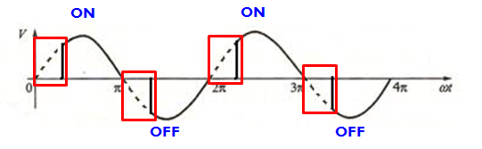 | Sometimes referred to as the ELV (electronic low voltage) dimmer this type of dimmer is usually found in commercial applications and high end residential.  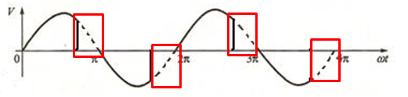
Originally formed in the NE by a number of utilities to help drive the utility rebate. It now evaluates and affirms the performance of LED luminaires relative to manufacturers’ claims.  It has a powerful influence on what utilities across the USA use as their standards for qualifying manufacturer’s products to qualify for utility incentives. | There are two photometric methods used to measure light output for lamps and luminaires. This one measures the total lumen output (gross) of the luminaire with lamp installed. Thus, lamp lumens and efficiency are not applicable and are not calculated or reported. LEDs use this method.

Exercise #3: Calculating “delivered or emitted” lumens

- Fluorescent
  - Initial Lumens: 3100 x 3 lamps
  - Mean/Design Lumens 2950 x 3 lamps
  - On a .87 Ballast _____ (ballast factor is a multiplier)
  - In a 75% Efficient Luminaire _____
  - % of Initial Lumens = _____
  - % of Initial Lumens lost = _____

- HID – Quartz Probe Start Metal Halide
  - Initial Lumens: 36,000
  - Mean/Design Lumens 24,000
  - On a 1.0 Ballast _____ (ballast factor is a multiplier)
  - In a 70% Efficient Luminaire _____
  - % of Initial Lumens = _____
  - % of Initial Lumens lost = _____

- CFL – 2 lamp – 32w 4 pin lamp
  - Initial Lumens: 2400 x 2
  - Mean/Design Lumens 2040 x 2
  - On a .93 Ballast _____ (ballast factor is a multiplier)
  - In a 60% Efficient Luminaire _____
  - % of Initial Lumens = _____
  - % of Initial Lumens lost = _____

(Show your work. Correct answers on the next page)

Exercise #3 – Delivered Lumens (Answers)

- Fluorescent
  - Initial Lumens: 3100 x 3 lamps = 9300 lumens
  - Mean/Design Lumens 2950 x 3 lamps = 8850 lumens
  - On a .87 Ballast 7700 (ballast factor is a multiplier)
  - In a 75% Efficient Luminaire 5775
  - % of Initial Lumens = 62%
  - % Initial Lumens lost = 38%

- HID – Quartz Probe Start Metal Halide
  - Initial Lumens: 36,000
  - Mean/Design Lumens 24,000
  - On a 1.0 Ballast 24,000 (ballast factor is a multiplier)
  - In a 70% Efficient Luminaire 16,800
  - % of Initial Lumens = 47%
  - % Initial Lumens lost = 53%

- CFL – 2 lamp – 32w 4 pin lamp
  - Initial Lumens: 2400 x 2 = 4800 lumens
  - Mean/Design Lumens 2040 x 2 = 4080 lumens
  - On a .93 Ballast 3794 (ballast factor is a multiplier)
  - In a 60% Efficient Luminaire 2277
  - % of Initial Lumens = 47%
  - % Initial Lumens lost = 53%

Note: This is a “delivered lumens” calculation without consideration for the actual
wattage consumption.

Exercise #4– Treasure Hunt (Covers the content in Chapter 5)

Introduction:

Learning about light and lighting begins with observing; looking at light and lighting. Let’s use a Treasure Hunt. Find and identify four light source types. Use the forms on the next 4 pages to document your search. If you are working in teams, first go out on your own. When you have found all of the sources you can on your own then collaborate. Work together to fill in any “missing source types”.

Physical Props:

Here is a list of the Physical Props you will need for this exercise, please gather them before you begin:
- Writing instrument (pen or pencil)
- Workbook
- Cell phone camera

What to Look For:

You are looking for four LED light source types:

- “Static Color” LED – one color: Red, Green, Blue or Amber – it’s a single color and it stays the same.
- “Dynamic Color” – a device that changes color, going from red, to magenta, to orange, to yellow etc. – it changes colors.
- “Static White” – one color of white - color temperature if fixed – 2700K remains 2700K even when dimmed to low light levels.
- “Dynamic White” – a device that changes color temperature, going from 2700K to 5000K – it changes the color temperature of a white light source.

(“Dynamic White” LED systems are harder to find. They change Kelvin temperature going from say 2700K through to 6500K. Try retrial, restaurants (it might be a lamp), offices hospital NICU)

You need to look indoors and outdoors. If you find a source and don’t know what it is, ask someone in the space, they may know. If they do, get as much information as you can about the source. Otherwise, consult with your coach.

This is a discovery exercise. Go out and have some fun learning about LED lighting.

Caution: If you cannot identify or get all of the information about a source from the ground, find someone on site who can help you get the necessary information from there. Do not get up on a ladder or other device unless your company has trained you in, and you are practicing, proper safety procedures, using all necessary and appropriate safety gear. Even after training, make sure to work with someone who knows and practices the proper safety procedures.

1. “Static Color” LED

Fixture or Lamp Type: Draw the fixture in the space below, trace the fixture on a sheet of paper, or take a picture and make a print. Cut it out and paste it here:

Shape of the LED Device: Draw the device or take a picture of the device, print the picture and put it in the space below. If the device is in or on something, make a drawing or take a picture of that:

LED base: If this is a retrofit lamp, draw the lamp base in the space below, trace the base from a drawing in your lamp catalog, or take a picture and print it. Cut it out and paste it here. If not skip this step:

LED Etch: (wattage, color temperature, operating voltage, etc.) You may have to enlist the help of someone in your company familiar with where these LED devices are. In some instance, the information may not be readily available (e.g. brake lights on a car or truck)

Does the Light Source use one of the following: (circle the one that applies, if any)

Yes No Ballast Yes No Low Voltage Transformer Yes No Driver

What is the Light Source Lighting – or – What does the Light source Do?

Describe the objects, and/or the activities, and “seeing” tasks that are going on, or being performed in the space:

OR

Describe the function the LED plays

Location:
Where inside or outside the building did you find the light source? Or is it embedded or attached to something like a vehicle, or embedded in a roadway, etc?

What type of room, space or object is it?

Is it in or on the ceiling, on the wall, free-standing, mounted on a pole, on a moving vehicle or projecting images on a screen?

Additional Notes:

2. “Dynamic Color” LED

Fixture or Lamp Type: Draw the fixture in the space below, trace the fixture on a sheet of paper, or take a picture and make a print. Cut it out and paste it here:

Shape of the LED Device: Draw the device or take a picture of the device, print the picture and put it in the space below. If the device is in or on something, make a drawing or take a picture of that:

LED base: If this is a retrofit lamp, draw the lamp base in the space below, trace the base from a drawing in your lamp catalog, or take a picture and print it. Cut it out and paste it here. If not skip this step:

LED Etch: (wattage, color temperature, operating voltage, etc.) You may have to enlist the help of someone in your company familiar with where these LED devices are. In some instance, the information may not be readily available (e.g. brake lights on a car or truck)

Does the Light Source use one of the following: (circle the one that applies, if any)

Yes No Ballast Yes No Low Voltage Transformer Yes No Driver

What is the Light Source Lighting – or – What does the Light source Do?

Describe the objects, and/or the activities, and “seeing” tasks that are going on, or being performed in the space:

OR

Describe the function the LED plays

Location:

Where inside or outside the building did you find the light source? Or is it embedded or attached to something like a vehicle, or embedded in a roadway, etc?

What type of room, space or object is it?

Is it in or on the ceiling, on the wall, free-standing, mounted on a pole, on a moving vehicle or projecting images on a screen?

Additional Notes:

3. “Static White” LED

Fixture or Lamp Type: Draw the fixture in the space below, trace the fixture on a sheet of paper, or take a picture and make a print. Cut it out and paste it here:

Shape of the LED Device: Draw the device or take a picture of the device, print the picture and put it in the space below. If the device is in or on something, make a drawing or take a picture of that:

LED base: If this is a retrofit lamp, draw the lamp base in the space below, trace the base from a drawing in your lamp catalog, or take a picture and print it. Cut it out and paste it here. If not skip this step:

LED Etch: (wattage, color temperature, operating voltage, etc.) You may have to enlist the help of someone in your company familiar with where these LED devices are. In some instance, the information may not be readily available (e.g. brake lights on a car or truck)

Does the Light Source use one of the following: (circle the one that applies, if any)

Yes No Ballast Yes No Low Voltage Transformer Yes No Driver

What is the Light Source Lighting – or – What does the Light source Do?

Describe the objects, and/or the activities, and “seeing” tasks that are going on, or being performed in the space:

OR

Describe the function the LED plays

Location:
Where inside or outside the building did you find the light source? Or is it embedded or attached to something like a vehicle, or embedded in a roadway, etc?

What type of room, space or object is it?

Is it in or on the ceiling, on the wall, free-standing, mounted on a pole, on a moving vehicle or projecting images on a screen?

Additional Notes:

4. Dynamic White LED

Fixture or Lamp Type: Draw the fixture in the space below, trace the fixture on a sheet of paper, or take a picture and make a print. Cut it out and paste it here:

Shape of the LED Device: Draw the device or take a picture of the device, print the picture and put it in the space below. If the device is in or on something, make a drawing or take a picture of that:

LED base: If this is a retrofit lamp, draw the lamp base in the space below, trace the base from a drawing in your lamp catalog, or take a picture and print it. Cut it out and paste it here. If not skip this step:

LED Etch: (wattage, color temperature, operating voltage, etc.) You may have to enlist the help of someone in your company familiar with where these LED devices are. In some instance, the information may not be readily available (e.g. brake lights on a car or truck)

Does the Light Source use one of the following: (circle the one that applies, if any)

Yes No Ballast Yes No Low Voltage Transformer Yes No Driver

What is the Light Source Lighting – or – What does the Light source Do?

Describe the objects, and/or the activities, and “seeing” tasks that are going on, or being performed in the space:

OR

Describe the function the LED plays

Location:

Where inside or outside the building did you find the light source? Or is it embedded or attached to something like a vehicle, or embedded in a roadway, etc?

What type of room, space or object is it?

Is it in or on the ceiling, on the wall, free-standing, mounted on a pole, on a moving vehicle or projecting images on a screen?

Additional Notes:

What, if anything, did you learn from your Treasure Hunt that you did not know before the exercise?

- “Static Color” LED

- “Dynamic Color” LED

- “Static White” LED

- “Dynamic White” LED

Add any notes here about your experience that you want to be sure you remember:

Exercise #5 – Comparing Life and Lumen Maintenance for LED and Traditional or Legacy sources (ANSWER KEY ON FOLLOWING PAGE)

Introduction:

Working with customers and colleagues requires that you know, understand and can talk about the similarities and differences between LED and “legacy sources”. This set of exercises will help you process what matters when you compare these sources.

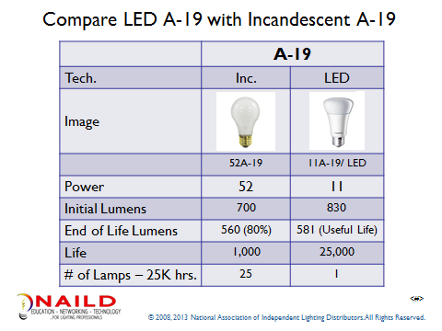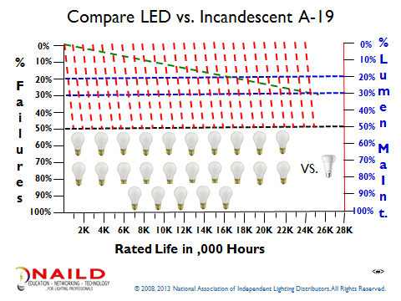

What does the data tell you?

- When you replace a 52W incandescent lamp with an 11W LED, what % of the energy do you save?
Answer: __________

- If the lights burn 14 hours per day, 5.5 days per week and 52 weeks a year (~ 4,000 hours), how many years will 25 light bulbs last? (round to the nearest whole number)
Answer: __________

- How many Watts of energy does each LED light bulb save? Answer: __________

- If “One Watt” of energy costs $0.40 per Watt per year (4,000 hrs. /1000 x $0.10/kWh), how much would your customer save per socket?
Answer: __________

- If it costs your customer $3 to change a light bulb, and the customer has to change four 1,000 hour light bulbs per year, what does the customer spend annually per socket?

Answer: _________

ANSWER KEY TO EXERCISE 5

- When you replace a 52W incandescent lamp with an 11W LED, what % of the energy do you save?
100% - (11w/52w or 21%) = Answer: ___79%_______

- If the lights burn 14 hours per day, 5.5 days per week and 52 weeks a year (~ 4,000 hours), how many years will 25 light bulbs last? (round to the nearest whole number)
25 lamps x 1,000 hrs = 25,000/ 4,000 = Answer: ___6 years____

- How many Watts of energy does each LED light bulb save?
52W – 11W = Answer: ___41W_____

- If “One Watt” of energy costs $0.40 per Watt per year (4,000 hrs./1000 x $0.10/kWh), how much would your customer save per socket?
41W x $0.40/W/year = Answer: __$16.40__

- If it costs your customer $3 to change a light bulb, and the customer has to change four 1,000 hour light bulbs per year, what does the customer spend annually per socket?

$3 x 4 changes = Answer: __$12.00 per year_

This concludes Module V -

