Module IV

WORKBOOK

NAILD LS I

The Eye and How We See

Copyright © NAILD. All Rights Reserved.

Chapter 1 – How the Eye Works

Each part of the eye plays a role in our ability to see and perform visual tasks. This is not an anatomy lesson. Rather it is a simplified review designed to help you understand what’s going on inside the eye and the role each part plays in seeing.

When you finish Chapter 1, you should know the role the following parts play in our ability to see:

- Cornea
- Pupil
- Lens
- Iris
- Retina
- Optic Nerve
- Fovea
- Rods
- Cones

For now, take this drawing of the eye and label the parts of the eye using the letters of the parts in the list above:

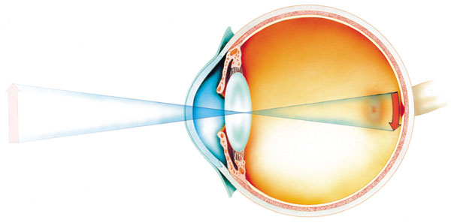

Do the best you can. This is not a test but merely a tool to help introduce or re-introduce you to these terms. When you finish, return to the online Module.

After you have finished this chapter, compare what you learned with your first attempt. And fill in the eye below with the correct answers.

You should know:

- What they are
- Where they are located, and
- What they do

Chapter 2 – What Affects Our Ability to See?

Before you perform the following exercises, complete the On-Line Module IV, Chapter 2.

Four Experiments

Now that you have seen the on-line version of the factors that affect our ability to see, let’s perform four short experiments so that you can experience these concepts:

What you will need to run these experiments:

- Access to a copy machine
- Yellow Hi-Liter Pen
- Black Permanent Ink Marker
- 8 ½ x 11 sheets of paper

Experiment #1 – Contrast: the difference in brightness between an object and its
background.

To experience this exercise, you will need to work with a colleague:

- Have your colleague write out two or three words in bold, capital letters on the 8½ x 11 sheet of paper using the black permanent ink marker. Leave a space large enough underneath the word, to write another word

- Standing about 12 – 15 feet away, try to read the words

- Now, below each of those words your colleague will write another word, this time, with the yellow Hi-Liter.

- Standing about 12 – 15 feet away, try to read the words

What happens, and why?

Experiment #2 – Size: not just the physical size but the size of the object in relation to
distinguishing characteristics that define it.

- On the next page is a quasi Eye Chart, similar to one you might find at the eye doctor. Make a copy of this, and put it up on the wall.

- Standing at a distance of 12 – 15 feet, read the chart. Is there a point where you cannot distinguish one letter from another? If you can see all of them clearly, move back another five feet until they blur.

What happened, and why?

What happens to your ability to see when you move closer or further from the chart?

E

R T F D

A P F C E

B G K L M Z

U O K J W P C D

T W S Q F L O M

Z C B N K L H F G

B P R D U Y V L I T

Experiment #3 – Time: it takes time to see detail, to discriminate one thing from
another
The key to this experiment involves experiencing how time affects your ability to see something.

- Method One: reading roadside billboards while traveling in a car
  - Look for a specific piece of information (e.g. phone number, location)

Describe your experience:

- Method Two: reading license plates while walking
  - Let the car pass (count one thousand one), and then look.

Describe your experience:

In Method One, did any of the following affect your ability to read the billboard?

- Size of the letters
- Amount of information on the billboard
- Familiarity with the message (i.e. the local McDonalds)
- Speed of the car
- Distance of the billboard from the roadway
- Contrast between the background of the billboard and the information you were trying to read

In Method Two, did any of the following affect your ability to read the license plates?

- Contrast between the license plate’s background and the color of the letters
- Speed of the car
- Whether or not there was a plastic sleeve or cover over the license plate
- “Vanity Plate” or standard plate
- Out-of-State vs. your State license plates
- Distance of the car when you started reading the plate
- Condition of the plate (dirt, snow, age, etc.)

Experiment #4 – Luminance: light reflecting off an object or target; it is the light we
see by.

Luminance can involve both the amount of light and the type and quality of light shining on an object. This experiment will include only the amount.

- Find a room where you can dim lights. This can be at home or at work.

- Collect some reading material. Some of the best are the drug companies “warning labels” and written instructions contained within a medicine or in a print ad in a magazine.

- Varying the amount of light, from high to low and back again, what do you experience?

- Why do you think that is?

Exercise #3 – Three Common Conditions That Affect Our Vision

For this Exercise, you will need to find:
- Someone who is near sighted
- Someone who is far sighted
- Someone 20 years older or 20 years younger than you

Near Sighted:
- Use the eye chart as used in the previous exercise.
  - Describe what happens

- Use a small paperback and ask the person to read a passage.
  - Describe what happens

Far Sighted:
- Use the eye chart as used in the previous exercise.
  - Describe what happens

- Use a small paperback and ask the person to read a passage.
  - Describe what happens

Age:
- Use the eye chart as used in the previous exercise.
  - Describe what happens

- Use a small paperback and ask the person to read a passage.
  - Describe what happens

This concludes Module IV

