Module II

WORKBOOK

NAILD LS I

Introduction to Sources

Chapter 1 – Light Sources - How They Operate & How They Fail

Chapter 2 – Lamp Terminology - 20 Terms You Need to Know

Chapter 3 – “Treasure Hunt” - Finding Sources in the Field

Bonus Section – Calculations You Should Know

Copyright © NAILD. All Rights Reserved.

Chapter 1 – How Sources Work

Here are five brief observational exercises that you can use while you are going through the Online Module II: Introduction to Sources.

Exercise #1 - Identifying and Observing Five Different Light Sources:

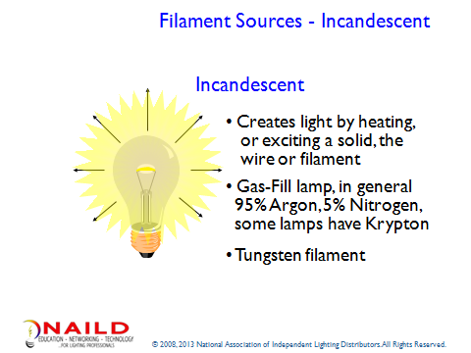

Review Slides 6 - 9 in the Introduction to Sources Module, and then do the Observation Exercise

Observation #1: Find an incandescent socket and a clear incandescent lamp.

- Turn on the light source
- Turn off the light source
- If you have a dimmer, use it with this source, what do you observe

The light source is instant _____ and instant _____.

When you dim an incandescent lamp what happens to its “color appearance”? It gets __________, softer, cozier.

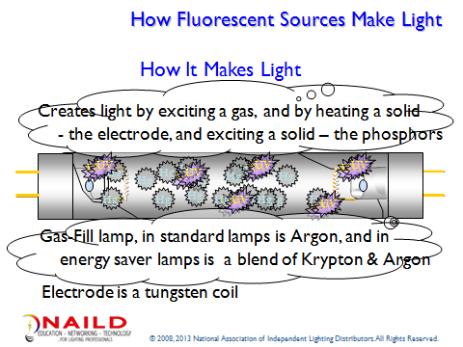

Review Slides 11 - 16 In the Introduction to Sources Module, and then do the Observation Exercise

Observation #2: Find a fluorescent fixture that you can turn on and off and see the lamps

- Turn on the light source
- Turn off the light source

The light source is instant _____and instant _____, or is there a slight delay?

What do you observe when the lamps come on?

- Does the light come on instantly?

- Is there a quick flicker before the lamps come on?

- Do the ends of the lamp glow and then you get light?

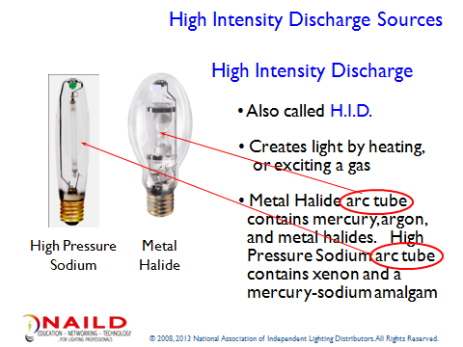

Review Slides 18 - 22 in the Introduction to Sources Module, and then do the Observation Exercise

Observation #3: Find an HID source that you can turn on and off, perhaps in the Warehouse.

- Turn the lamp on and let it run for a few minutes or observe it going on.
- If possible, turn it off and turn it back on.

  - Describe what happened:

  - How long before the lamp came back on?

Note:
- If you don't have HID in the Warehouse, observe HID when the Street Lights come on or when the lights in a Parking Lot come on.
- Find a "clear" HID lamp - High Pressure Sodium or Metal Halide (Ceramic or Quartz) and observe the arc tube (Warehouse or local DIY store). If you do not know what to look for, get help from someone.

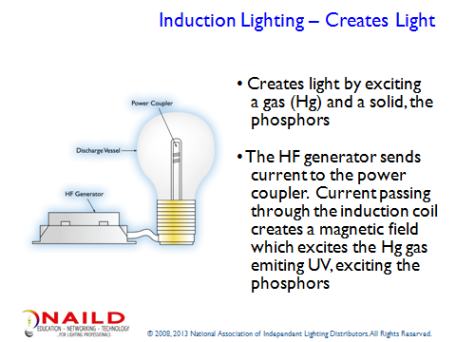

Review Slides 24 - 26 in the Introduction to Sources Module, and then do the Observation Exercise

Observation #4: Find an Induction lamp that you can turn on and off, and see the lamp

- Turn the lamp on and let it run for a few minutes.

- Now turn it off and turn it back on.

- Describe what happened:

If you are not familiar with this source, look it up online.

Note: here is a link to an animation showing the operation of an Induction system.

http://wn.com/induction_lamps

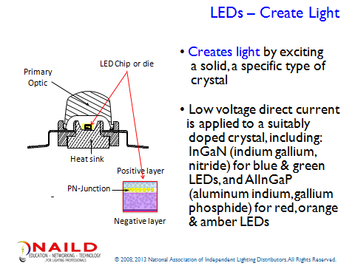

Review Slides 28 - 30 in the Introduction to Sources Module, and then do the Observation Exercise

Observation #5: Find an LED source that you can turn on and off, and see the LEDs in the luminaire (fixture).

- Turn the lamp on and let it run for a few minutes.

- Now turn it off and turn it back on.

- Describe what happened: The light source is instant _____ and instant _____.

- What do you notice is different about LEDs in relation to the other sources?

Chapter 2 – Lamp Terminology

For this exercise, you will need to photocopy the Lighting Terms and the Definitions on pages 10 – 13 of this Workbook, ten 3 x 5 cards, and a glue stick or adhesive, so that you can keep your Workbook intact.

Exercise #2: Making Lighting Vocabulary Flash Cards:

Step one: Photocopy and cut out the Lighting Terms and the Definitions on pages 10 – 13.

Step two: On your own, match the Lighting Terms and the Definitions.

Step three: Using the PowerPoint presentation as a reference, confirm your matches and then, using the 3 x 5 cards glue the Lighting Term to one side and its Definition to the other to create your ten Lighting Terminology Flash Cards.

Step four: Repeat the same process with the second group of ten terms.

Physical Props:

- 3 x 5 cards
- Adhesive, glue stick or rubber cement
- Lamp Catalog
- Ballast Catalog
- Workbook

References:

DiLouie, Craig, “Lighting Management Handbook”, Fairmont Press, 1994
Gordon, Gary, and Nuckolls, James L. “Interior Lighting for Designers, Fourth Edition. John Wiley & Sons, Inc., New York, 2003.

Lamp Shape | Color Temperature
Color Rendering Index | Lumens
KW | KWH
Rated Average Life | Size
Arc Tube | Lamp Base

A pressurized clear quartz glass or ceramic enclosure within the outer glass envelope of an HID lamp containing metals and other chemicals that when under pressure, under high temperature vaporize within the arc stream and create visible light. It requires a ballast to provide the proper starting voltage and regulate the lamp operating current. | This is a unit of measure for the quantity of light leaving the lamp. It is sometimes referred to as the flow of light in all directions.  The technical term is luminous flux.
Used to describe whether a lamp is arbitrary, tubular, ellipsoidal, PAR, bulge tubular, etc. | Often referred to as the “color appearance” or the “look and feel” of a light source – “cool and crisp”, “warm and cozy”.
Typically it is the number of hours of runtime before 50% of a large field lamps burn out. So, in a field of 1000 lamps, the point, in hours where 500 remain lighted. Fluorescent lamp life is based on three (3) hour/start. HID lamp life is based on ten (10) hours per start. DiLouie: p. 16 | An electric utility, bills its commercial and institutional customers for “power”, known as “demand ” and for “energy”, known as  _________ or kilowatt hours
The ability of a light source to reflect back to the eye the colors we expect to see in an object or a target. Ranked on a scale of 0 to 100, incandescent, Halogen and daylight are considered reference sources (Ranked 100) | Defines the type of socket required to hold the lamp and provide a solid electrical connection.
The electric bill of most businesses and large institutions are charged every month for the highest amount of “power” that they “demanded” from their local utility. The unit of measure for “demand” or “power”, is  _________ or kilowatts | When we see T12, ED-17, A-19, the number portion of this lamp description is the lamp diameter at its widest point in 1/8ths of an inch. Example t12 = 12 1/8ths or 1 ½ inches

LED | "Useful Life"
Initial Lumens | Mean/Design Lumens
MBCP/CBCP | ANSI Code/Ballast Ref.
Filament Source | Ballast
Fluorescent | High Intensity Discharge

Describes how much light a lamp produces once a lamp is stabilized, or burned in, for 100 hours. DiLouie: p. 4. | Mean lumens reveals the average light output at 40% of rated lamp life.  DiLouie: p. 4.
A low-pressure mercury arc discharge source that produces visible light when an electrical arc passing between two cathodes, excites mercury ions to a higher energy state. As they pass toward the bulb wall, they give off UV. The UV excites the phosphors on the lamp wall, causing them to glow and produce visible light.. It requires a ballast to provide the proper starting voltage and regulate the lamp operating current. Gordon: pp. 81-87, 280 | A device in the electrical circuit of gas discharge lamps that provides the lamp starting voltage and controls the current during lamp operation.
A semiconductor that produces visible light when current is applied to the device. It is a monochromatic light source. | An arc-discharge source with a high-power density, produced by passing electric current through a gas or vapor under high pressure. Lamps belong to three principal families: (1) mercury-vapor, (2) metal –halide, and (3) high-pressure sodium. It requires a ballast to provide the proper starting voltage and regulate the lamp operating current. Gordon: pp. 93- 97
This is a measure of beam intensity. The unit of measure is the candela or candle power. Both mean the same thing – the spot in the beam that is the brightest when measured with a footcandle meter. | This term describes when an LED device reaches 70% of its initial light output for illumination grade LEDs (devices that light retail, office, industrial, etc. spaces) and 50% for decorative LEDs.
An electric current passing through the wire heats a wire until it incandesces and the wire emits light. A wire is sealed in a glass bulb or a burner. The wire diameter and length determine the amount of electrical current consumed by the lamp, regulating its light output. Gordon: pp. 63- 72 | When looking in a lamp catalog for an HID or High Intensity Discharge source, this data includes the specific ballast designed to operate that particular lamp. Example: 400w Metal Halide Switch Start uses a M-59 ballast. For Metal Halide lamps, additional information includes whether you may use the lamp in an Open or Enclosed luminaire.

Chapter 3 – The Treasure Hunt

Exercise #3: Conducting Your Treasure Hunt:

Learning about light and lighting begins with observing; looking at light and lighting. Let’s start with a Treasure Hunt. Your task is to find and identify six light sources. Use the forms on the following pages to document your search.

Physical Props:

Here is a list of the Physical Props you will need for this exercise, please gather them before you begin:
- Writing instrument (pen or pencil)
- Workbook pages

What to Look For:

You must find one of each of the following light sources:

- Incandescent and/or Halogen
- Compact Fluorescent (CFL) – Integrated - think of the "Twister" - the ballasts is part of the lamp or Compact Fluorescent (CFL) – Non-Integrated - ballast is separate - most commonly found in a downlight
- Linear Fluorescent
- High Intensity Discharge (HID – 175w – 400w)
- Induction Light Source
- Light Emitting Diode (LED)

You may look indoors and outdoors. You may limit your search to the facility where you work, or, with permission from your manager or supervisor, visit another facility (indoors or outdoors) to find and identify your sources. One last reminder, if you find a source and don’t know what it is, ask someone in the space, they may know. If they do, try and get as much information as you can about the source. If you cannot find the source in the field search online.

This is not a test or a quiz. It is a discovery exercise. Go out and have some fun learning about light and lighting.

Caution: If you cannot identify or get all of the information about a source from the ground, go to where these lamps are stored and get the necessary information from there. Do not get up on a ladder or other device unless your company has trained you in, and you are practicing, proper safety procedures, using all necessary and appropriate safety gear. Even after training, make sure to work with someone who knows and practices the proper safety procedures
1. Filament Source – Incandescent or Halogen

Fixture Type: (Table Lamp, Downlight, Track Fixture, Chandelier, Sconce, Outdoor Decorative, Post Top)

Draw the fixture in the space below, or trace the fixture on a sheet of paper, cut it out and paste it here:

Shape of the lamp: Draw the lamp in the space below, or trace the lamp in your lamp catalog, onto a sheet of paper, cut it out and paste it here:

Lamp base: Draw the lamp base in the space below, or trace the base from a drawing in your lamp catalog, onto a sheet of paper, cut it out and paste it here:

Lamp Etch: (wattage, lamp code (e.g. F32T8/735)) write it here: (You may have to enlist the help of someone in your company familiar with where these lamps are stored, if the location of the lamp is too difficult to get to and reach the lamp inside the fixture.)

Does the Light Source use one of the following: (circle the one that applies, if any)

Yes No Ballast Yes No Low Voltage Transformer Yes No Driver

What "seeing tasks" take place in the room or space that this light source lights?

Describe the objects, and/or the activities, and “seeing” tasks that are going on, or being performed in the space:

Location:

Where inside or outside the building did you find the light source?

What type of room or space is it?

Is it in or on the ceiling, on the wall, free-standing, mounted on a pole?

Additional Notes:

2. Compact Fluorescent (CFL) – Integrated: (means the lamp and the ballast are one piece), or Non-Integrated: (means that the ballast and the lamp are separate). You will find these sources in locations similar to those used for Incandescent and Halogen.

Fixture Type: Draw the fixture in the space below, or trace the fixture on a sheet of paper, cut it out and paste it here:

Shape of the lamp: Draw the lamp in the space below, or trace the lamp in your lamp catalog, onto a sheet of paper, cut it out and paste it here:

Lamp base: Draw the lamp base in the space below, or trace the base from a drawing in your lamp catalog, onto a sheet of paper, cut it out and paste it here:

Lamp Etch: (wattage, lamp code (e.g. F32T8/735)) write it here:_________________________
(You may have to enlist the help of someone in your company familiar with where these lamps are stored, if the location of the lamp is too difficult to get to and reach the lamp inside the fixture.)

Does the Light Source use one of the following: (circle the one that applies, if any)

Yes No Ballast Yes No Low Voltage Transformer Yes No Driver

What "seeing tasks" take place in the room or space that this light source lights?

Describe the objects, and/or the activities, and “seeing” tasks that are going on or being performed in the space:

Location:

Where inside or outside the building did you find the light source?

What type of room or space is it?

Is it in or on the ceiling, on the wall, free-standing, mounted on a pole?

Additional Notes:

3. Linear Fluorescent: (Strip lights, 2x 4 Recessed Troffers, Industrial Hooded fixtures, High Bay fluorescent, etc.)

Fixture Type: Draw the fixture in the space below, or trace the fixture on a sheet of paper, cut it out and paste it here:

Shape of the lamp: Draw the lamp in the space below, or trace the lamp in your lamp catalog, onto a sheet of paper, cut it out and paste it here:

Lamp base: Draw the lamp base in the space below, or trace the base from a drawing in your lamp catalog, onto a sheet of paper, cut it out and paste it here:

Lamp Etch: (wattage, lamp code (e.g. F32T8/735)) write it here: ________________________

Does the Light Source use one of the following: (circle the one that applies, if any)

Yes No Ballast Yes No Low Voltage Transformer Yes No Driver

What "seeing tasks" take place in the room or space that this light source lights?

Describe the objects, and/or the activities, and “seeing” tasks that are going on, or being performed in the space.

Location:
Where inside or outside the building did you find the light source?

What type of room or space is it?

Is it in or on the ceiling, on the wall, free-standing, mounted on a pole?

Additional Notes:

4. High Intensity Discharge (HID): (in lower wattages, Retail, Supermarkets, in higher wattages, Industrial, Big Box Retail, Street Lighting, Wall Packs, Gas Station Canopies, etc.)

Fixture Type: Draw the fixture in the space below, or trace the fixture on a sheet of paper, cut it out and paste it here:

Shape of the lamp: Draw the lamp in the space below, or trace the lamp in your lamp catalog, onto a sheet of paper, cut it out and paste it here:

Lamp base: Draw the lamp base in the space below, or trace the base from a drawing in your lamp catalog, onto a sheet of paper, cut it out and paste it here:

Lamp Etch: (wattage, lamp code (e.g. F32T8/735)) write it here: _____________________________

Does the Light Source use one of the following: (circle the one that applies, if any)

Yes No Ballast Yes No Low Voltage Transformer Yes No Driver

What "seeing tasks" take place in the room or space that this light source lights?

Describe the objects, and/or the activities, and “seeing” tasks that are going on, or being performed in the space:

Location:

Where inside or outside the building did you find the light source?

What type of room or space is it?

Is it in or on the ceiling, on the wall, free-standing, mounted on a pole?

Additional Notes:

5. Induction Light Source: (usually harder to locate, some used in Street Lighting or parking Garages)

Fixture Type: Draw the fixture in the space below, or trace the fixture on a sheet of paper, cut it out and paste it here:

Shape of the lamp: Draw the lamp in the space below, or trace the lamp in your lamp catalog, onto a sheet of paper, cut it out and paste it here:

Lamp base: Draw the lamp base in the space below, or trace the base from a drawing in your lamp catalog, onto a sheet of paper, cut it out and paste it here:.

Lamp Etch: (if possible (e.g. F32T8/735)) write it here: __________________________

Does the Light Source use one of the following: (circle the one that applies, if any)

Yes No Ballast Yes No Low Voltage Transformer Yes No Driver

What "seeing tasks" take place in the room or space that this light source lights?

Describe the objects, and/or the activities, and “seeing” tasks that are going on, or being performed in the space:

Location:

Where inside or outside the building did you find the light source?

What type of room or space is it?

Is it in or on the ceiling, on the wall, free-standing, mounted on a pole?

Additional Notes:

6. Light Emitting Diode (LED): (Today, you can find them almost anywhere you would find traditional light sources)

Fixture Type: Draw the fixture in the space below, or trace the fixture on a sheet of paper, cut it out and paste it here:

Shape of the lamp: Draw the lamp in the space below, or trace the lamp in your lamp catalog, onto a sheet of paper, cut it out and paste it here:

Lamp base: Draw the lamp base in the space below, or trace the base from a drawing in your lamp catalog, onto a sheet of paper, cut it out and paste it here:

Lamp Etch: (wattage, lamp code (e.g. F32T8/735)) write it here: ____________________________.

Does the Light Source use one of the following: (circle the one that applies, if any)

Yes No Ballast Yes No Low Voltage Transformer Yes No Driver

What "seeing tasks" take place in the room or space that this light source lights?

Describe the objects, and/or the activities, and “seeing” tasks that are going on, or being performed in the space:

Location:

Where inside or outside the building did you find the light source?

What type of room or space is it?

Is it in or on the ceiling, on the wall, free-standing, mounted on a pole?

Additional Notes:

What did you learn from your Treasure Hunt about these light sources that you did not know before the exercise?

- Incandescent and/or Halogen

- Compact Fluorescent (CFL) – Integrated and/or Non-Integrated

- Linear Fluorescent

- High Intensity Discharge

- Induction

- Light Emitting Diode (LED)

Add any notes here about your experience that you want to be sure you remember:

Exercise #4: Calculations You Should Know
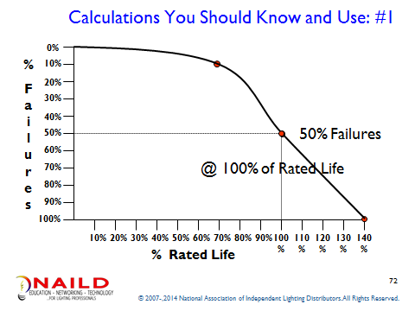

- Lighting Maintenance Contractors recommend changing out lamps in a facility at the point when 10% of the lamps have failed. At what % of Rated average life does the lamp failure rate reach 10%? (Use you pen/pencil and a straight edge to draw in a line.)

- If the facility operates its lamps for 4,000 hours per year, and uses a fluorescent T8 rated at 36,000 hours, how many years, how many years between installation and the time for planned maintenance or group re-lamping?

  - What is 70% of 36,000 hours?

  - What is that number divided by 4,000 hours per year? (that will be you answer in “number of years”)

- What % of the lamps will fail between the recommended time for planned maintenance and the time all of the lamps will fail?

  - What is 100% - 10%?
  - Over what time will this failure occur?

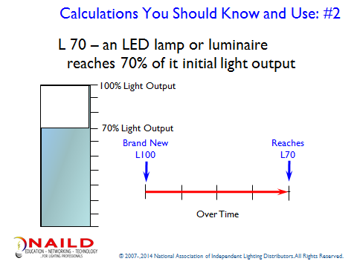

- If the lamp produces 1200 lumens initially - What is 70% of the initial lumens? How many lumens will the LED assembly produce at 45,000 hours?

- Does L 70 tell you what the lamp will produce or just what the LED assembly is expected to produce?

- What else could fail in the lamp?

Return to the On-line presentation and take the Module II Quiz.

After the Quiz, return to your Workbook and write an outline of what you learned in Module II during the:

- How Sources Work

- Language of Lamps

- Treasure Hunt

- Calculations You should Know

What questions or concerns do you have about what you have learned?

You can use one or both sides of this page. Remember this workbook will become part of your lighting library. Make sure to take the time to remind yourself what you have learned so far. Collaborate with your teammate(s) and seek out the assistance of a mentor.

When you have completed Module II, give yourself at least 24 hours before continuing. This will allow your mind the time it needs to process everything that you have experienced.

This concludes Module II

